traffic light irregularities detection system

Using Deep Learning – YOLO V8 MODEL

UNIVERSITY COLLEGE OF ENGINEERING

OSMANIA UNIVERSITY

*SUMMER INTERNSHIP PROJECT REPORT*

*BHANU**SUMANTH**DONTHALA*

*1005-20-733013*

*VAMSI**KRISHNA**DUSSA*

*1005-20-733014*

**TRAFFIC LIGHT IRREGULARITIES DETECTION SYSTEM USING**

**DEEP-LEARNING YOLO V8 MODEL**

**SUMMER INTERNSHIP PROJECT REPORT**

*SUBMITTED BY:*

***BHANU SUMANTH DONTHALA* (100520733013)**

***DUSSA VAMSI KRISHNA*  (100520733014)**

In partial fulfilment for the award of the degree

of

**BACHELOR OF ENGINEERING**

IN

**Computer Science and Engineering**

**University College of Engineering**

**OSMANIA UNIVERSITY: HYDERABAD-500007**

OCTOBER - 2023.



Department of Computer Science and Engineering,

University College of Engineering,

Osmania University.

**CERTIFICATE:**

This is to certify the bonafide work of **D. BHANU SUMANTH, DUSSA VAMSI KRISHNA** bearing roll numbers **100520733013, 100520733014** respectively, for their SUMMER INTERNSHIP project, in partial fulfilment of

Bachelor of Engineering Degree,

offered by

Department of Computer Science and Engineering, University College of Engineering, Osmania University.



Project guide Head of the Department

Prof. Dr. P.V. SUDHA Prof. Dr. P.V.SUDHA

Department of CSE, OU. Department of CSE, OU.

**STUDENT DECLARATION**

We declare that the work reported in the project report entitled **“Traffic Light Irregularities Detection System using Deep Learning”** submitted by **Donthala Bhanu Sumanth and Dussa Vamsi Krishna** is a record of the work done by us in the **Department Of Computer Science and Engineering, University College of Engineering, OSMANIA UNIVERSITY**. No part of the report is copied from books/ journals/internet and wherever referred, the same has been duly acknowledged in the text. The reported data is based on the work done entirely by us and not copied from any other source or submitted to any other Institute or University for the award of a degree or diploma.

**Signatures**

Bhanu Sumanth:

Vamsi Krishna:

**Acknowledgement**

It is our privilege and pleasure to express our profound sense of respect, gratitude and indebtedness to our guide and Head of the Department of Computer Science and Engineering **Prof**. **Dr. P.V. SUDHA** for her inspiration, guidance, cogent discussion, constructive criticisms, and encouragement throughout this dissertation work and for her support from the Department and allowing all the resources available to us students.

We would also like to extend our thanks to the entire faculty of the Department of Computer Science and Engineering, University College of Engineering, Osmania University, who encouraged us throughout the course of our bachelor’s degree and allowing us to use as many resources present in the department. Our sincere thanks to our parents and friends for their valuable suggestions, morals, strength and support for the completion of our project.

**ABSTRACT**

Irregularities in traffic lights can endanger both automobiles and pedestrians. To solve this issue, we offer a deep learning model that can accurately recognise traffic light abnormalities. Our model was trained on a huge dataset of real-world traffic signal photos with a range of anomalies, including:

* **No yellow state:** The traffic light does not transition from red to yellow to green, but instead jumps from (red to green) or (green to red). Increasing the likelihood of an accident.
* **Broken signal:** The traffic light is broken and is trapped in a single signal condition.
* **Obstructed signal:** The traffic light is obscured by trees, buildings, or other obstacles, making visibility difficult or impossible for automobiles and pedestrians.

Our model is divided into two parts: a traffic light detection module and a traffic light categorization module. The traffic light detection module detects traffic lights in video frames using YOLOv8. The detected traffic lights are subsequently sent into the traffic light classification module, which categorises them as regular operating traffic lights or other irregular traffic lights.

**Application possibilities:-** Our concept might be used to create a wide range of applications, including:

* A smartphone app that allows vehicles and pedestrians to notify authorities about traffic signal violations.
* A system capable of automatically detecting and reporting traffic signal inconsistencies to authorities.
* A system that can be used by traffic engineers to identify and address areas with a high frequency of traffic light irregularities.

What distinguishes our model from its predecessor is its capacity to categorise traffic light films using YOLOv8 faster than previous models, as well as its ability to classify them based on the sequence of traffic states. So, using videos, we can detect irregular traffic lights, such as whether or not a traffic light is in the yellow condition.

In summary, the system is intended to outperform past techniques as dataset sizes get larger.

**Table of Contents**

|  |  |  |
| --- | --- | --- |
| S.no | Content | P.no. |
| 1. | **Chapter 1: Introduction**   * 1. Aim | **7** |
| 2. | **Chapter 2: Literary Survey** | **10** |
| 3. | **Chapter 3: Existing Methods**  3.1 Canny edge detection operator  3.2 Kirsch edge detection operator  3.3 Sobel edge detection operator  3.4 Roberts edge detection operator  3.5 Prewitt edge detection operator | **11** |
| 4. | **Chapter 4: Proposed Solutions**  4.1 Proposed Approach  4.2 Approach | **16** |
| 5. | **Chapter 5: Implementation**  5.1 Environmental Setup  5.2 Training the Data Setup | **23** |
| 6. | **Chapter 6: Results**  6.1 Loss & Accuracy Curves  6.2 Train batch data  6.3 Validation batch data  6.4 Testing of predict_on_video() function on videos | **29** |
| 7. | **Chapter 7: Conclusion and Future Scope**  7.1 Conclusion  7.2 Future Scope | **37** |
| 8. | **Chapter 8: References** | **39** |
| 9. | **Chapter 9: Appendix** | **41** |

**CHAPTER 1**

**INTRODUCTION**

* 1. **AIM**

Traffic light detection technology can help drivers to identify the status of traffic lights and make decisions quickly according to the identified status of traffic lights. This can reduce driver distraction and prevent the occurrence of non-standard driving and illegal behavior. Therefore, this research on a traffic light detection and recognition model with a high accuracy in real-time has practical significance and broad development prospects for improving road traffic safety. Traffic light detection systems often use industrial cameras to collect road condition information. Due to the complexity and changeability of the traffic light image background in real traffic scenarios, the traffic light in an image occupies less pixels and its feature structure is sparse, which increases the difficulty of algorithm recognition. Therefore, it is very important to study a more effective small target detection algorithm for traffic signal light detection [[**1**](https://www.mdpi.com/1424-8220/22/1/200#B1-sensors-22-00200),[**2**](https://www.mdpi.com/1424-8220/22/1/200#B2-sensors-22-00200)].

Traffic light detection has undergone several years of development, and many excellent detection methods have been reported. At present, these methods can mainly be divided into two categories [[**3**](https://www.mdpi.com/1424-8220/22/1/200#B3-sensors-22-00200)]: one is based on traditional algorithms using image processing and machine learning, while the other is based on deep learning.

The use of traditional algorithms in traffic light detection has been widely investigated. In [[**4**](https://www.mdpi.com/1424-8220/22/1/200#B4-sensors-22-00200)], the authors located the position of the traffic light by converting the color image to a YCbCr color space. The problem of low detection and recognition accuracy due to traffic lights being a small target and only using their color and shape information was solved by taking advantage of Gabor wavelets’ sensitivity to image edges. At the same time, the authors extracted the features using two-dimensional independent component analysis and completed the traffic light classification by sending the features to the nearest neighbor classifier. In [[**5**](https://www.mdpi.com/1424-8220/22/1/200#B5-sensors-22-00200)], the authors converted an RGB image to LUV color space on the basis of sliding window detection, used the aggregate channel features (ACFs) algorithm for training, then completed the detection of traffic lights. The authors of [[**6**](https://www.mdpi.com/1424-8220/22/1/200#B6-sensors-22-00200)] proposed a multi-scale traffic signal detection method based on the ACF algorithm and an enhanced tree classifier. This method used a feature pyramid to fuse features and was able to effectively detect red and green traffic lights. In [[**7**](https://www.mdpi.com/1424-8220/22/1/200#B7-sensors-22-00200)], the authors proposed the use of a fast image segmentation and compression algorithm based on color to improve computational efficiency, introduced the time–space model of multi-frame image sequences to improve the accuracy of traffic light detection, and combined these with support vector machines to identify traffic lights through the histogram feature of the oriented gradient of the image. The above methods can realize the detection of traffic lights to a certain extent; however, traditional algorithms still face great challenges in practice due to their poor generalization ability and limited detection speed.

The target detection algorithm based on deep learning was thus developed for the detection of traffic lights to overcome the limitations of traditional algorithms.

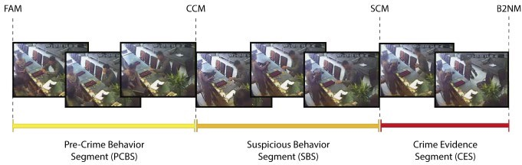

***Figure 1 Video segmentation by using the moments obtained from the Pre-Crime Behaviour Segment (PCB) method.***

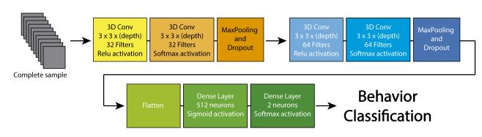

***Figure 2 Architecture of the DL Model used.***

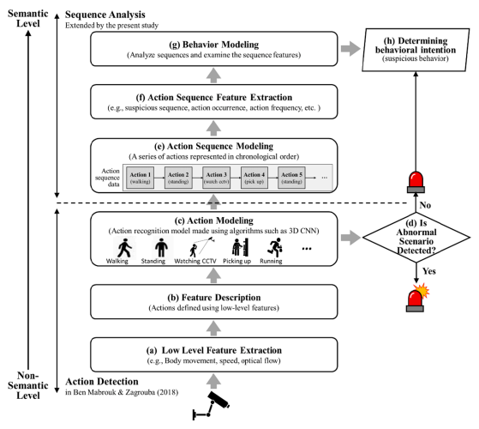

**CHAPTER 2**

LITERARY SURVEY

The research on traffic light detection is widely present in literature. The presence of traffic lights in urban environments could not be ignored by research groups developing advanced driver assistance systems or working on the topic of autonomous driving. Radio Frequency IDentification (RFID), and other Vehicle-to-Infrastructure (V2I) communication technologies could potentially substitute traffic lights in an autonomous vehicles only scenario. However, in a mixed manual-autonomous vehicle situation – more likely to happen in the near future – traffic control will still need traffic lights, especially in urban traffic networks.

The main contribution of our research is to design a robust system which detects suspended traffic lights in real-time. Such proposal system has been tested in a wide variety of illumination intensity during day (from early morning to early evening) and night.

As an additional novel contribution, a study is presented in reference to the way in which the algorithm estimates distance between suspended traffic lights and the vehicle. Bayesian filters, such as Kalman Filter and Particle filter, are analyzed to compute the reckoned distance. Such Bayesian Filter are well-known and applied to a large number of computer vision problems in intelligent transportation systems, like the lane tracking (Nieto, Cortés, Otaegui, Arróspide, & Salgado, 2012). Estimated distance is also used to enhance detection results, excluding a large number of false detections in tracking stage. The system achieves positive results at different vehicle urban speeds, using a single camera. Through ground truth provided by an integrated laser scanner in our test platform, our method has been able to detect suspended traffic lights from 115 to 10 m. The detection results are validated using more than one hour of video (7388 detections during the day and over 11000 detections during the night) and the distance results are validated with 2700 correct detections. A digital map of the studied area could help to reduce some false positives and to save processing time: a first test using a map has been already carried out. Computational times have been reduced by parallelizing the method functions to achieve the real time processing.

**CHAPTER 3**

**EXISTING METHODS**

In the theory of digital image processing, image edge is one of the basic features of the image. Image edge detection is not only the detection of the boundary, but also the place where the attributes of two regions mutate. Image edge detection is an accurate and efficient detection of the boundary between a certain type of specific object and its background through scientific and reasonable algorithm. The main steps can be divided into image analysis, image recognition, boundary reconstruction and extraction. At present, digital image edge detection methods can be mainly divided into three categories: One is based on a fixed local operation method, which is mainly based on the local simplified mathematical basis and its principle, such as differential and integral method and fitting method. This kind of method belongs to the classical edge detection method. The second is global extraction method based on energy minimization rule, the basic idea to use rigorous mathematics theory method is reasonable and accurate analysis to the problem, its most optimal detection based on one dimensional cost function is given, from the point of view of the global optimal for image edge detection, this kind of method for mathematical logic is relatively tight, Such as neural network analysis and principal component analysis; The third kind of method is the new image edge detection method supported by the high-tech technologies that have developed rapidly in recent years, such as wavelet transform and mathematical morphology. This kind of algorithm can combine the traditional simple image edge detection theory with the latest theoretical methods, and then integrate into the latest developed deep learning technology. Finally, it can provide a reference for the basic method of image edge detection theory in artificial intelligence learning.

From the concept of image edge, we can know that image edge is the position where the gray level of the image changes significantly. The algorithm principle based on image edge feature and gradient theory is as follows:

$$∇f\left(x,y\right)=\frac{∂f}{∂x}i+\frac{∂f}{∂y}j=f_{x}\left(x,y\right)i+f_{y}\left(x,y\right)j.$$

At the same time:

$$E\left(x,y\right)=\sqrt{f_{x}^{2}\left(x,y\right)+f_{y}^{2}\left(x,y\right)}.$$

It is the amplitude of the gradient $∇f(x,y)$  can be used as an edge extraction operator. For the sake of memorization, we can simplify the calculation and define E(i,j) as the sum of the absolute values of the two, namely:

$$E(x,y)=|f_{x}(x,y)|+\left|f_{y}\left(x,y\right)\right|.$$

According to the above theory, many image edge extraction algorithms are derived. As for the dynamic change of image gray level, it can be accurately and objectively expressed by the gradient of image gray level function. Therefore, the image edge extraction algorithm can be obtained by the image local differential technology, which is convenient, practical and widely used at present.

### **3.1. Canny edge detection operator**

Canny operator is an image edge detection algorithm proposed by John Canny in 1986. At present, it has become one of the classic algorithms in the field of digital image processing. Canny edge detection operator is a multi-level detection operator. Its basic principle and basic processing flow are as follows: Gaussian smoothing filter is carried out on the original image to smooth the image and filter out noise; Then, the gradient intensity and direction of each pixel were calculated respectively. Then, the non-extreme suppression technology was used to eliminate the influence of stray edges, and the real and potential edges were determined by double threshold detection. Finally, edge detection was completed by suppressing isolated weak edges, and the Canny edge detection processing image was obtained.

1) Gaussian filter smoothing the image.

Canny operator uses Gaussian filter to reduce the impact of noise, through the convolution processing with the image, filter out the noise in the image, and smooth the image.

2) Calculate the gradient amplitude and direction of the image.

When the Canny operator obtains the gradient image, the 2×2 template is used to calculate the gradient amplitude and gradient direction of the gray image. The gradient value in both horizontal and vertical directions is:

$$\begin{aligned}G_{x}(i,j)=\left[I\left(i,j+1\right)-I\left(i,j\right)+I\left(i+1,j+1\right)-I\left(i+1,j\right)\right]/2, \\ G_{y}(i,j)=\left[I\left(i,j\right)-I\left(i+1,j\right)+I\left(i,j+1\right)-I\left(i+1,j+1\right)\right]/2.\end{aligned}$$

At this time, the magnitude of the gradient at (i,j) is G(i,j), the gradient directions Θ(i,j) are respectively:

3) Non-maximum suppression of the gradient amplitude is performed.

A 3×3 template window is used for the small neighborhood in the gradient amplitude graph G(i,j), in which the central pixel is compared with its adjacent pixels in the gradient direction. If the value of the center pixel is not greater than the value of the adjacent pixels along the gradient, it is set to zero. Otherwise, this is a local maximum, so leave it there.

4) The double threshold method detects and connects the edges.

After non-maximum suppression, the image is extracted by double threshold with high threshold Tℎ and low threshold Tl, and the false edge is eliminated and the discontinuous edge is connected. If the gradient value of the edge point after non-maximum suppression is greater than the high threshold, it is retained as the edge point. The point where the gradient value is less than the low threshold value is deleted; For a point whose gradient value is between two thresholds and is adjacent to the edge point, it is necessary to judge whether there is any edge pixel greater than the high threshold value in its 8 neighborhoods. If there is, it will be retained as the edge point, otherwise it will be deleted.

### **3.2. Kirsch edge detection operator**

Kirsch operator is one of the classical edge detection operators, which is still widely used today. In 1971, R. Kirsch proposed a method of calculating the gradient of image pixels in clockwise cycle to carry out edge detection. Assume a 3×3 neighborhood of one pixel, and take the gradient size of the edge as:

$$m\left(i,j\right)=max\left\{1,max\left\{\left|5s_{k}-3t_{k}\right|,k=0,1,…,7\right\}\right\}.$$

In the formula:

$$s_{k}=a_{k}+a_{k+1}+a_{k+2},t_{k}=a_{k+3}+a_{k+4}+⋅⋅⋅+a_{k+7}.$$

When *k*= 0, 1,..., 7, the following eight templates are used:

$$\begin{aligned}\underset{M_{0}}{\left[\begin{matrix}5 & 5 & -3 \\ 5 & 0 & -3 \\ -3 & -3 & -3\end{matrix}\right]}\underset{M_{1}}{\left[\begin{matrix}5 & 5 & 5 \\ -3 & 0 & -3 \\ -3 & -3 & -3\end{matrix}\right]}\underset{M_{2}}{\left[\begin{matrix}-3 & 5 & 5 \\ -3 & 0 & 5 \\ -3 & -3 & -3\end{matrix}\right]}\underset{M_{3}}{\left[\begin{matrix}-3 & -3 & 5 \\ -3 & 0 & 5 \\ -3 & -3 & 5\end{matrix}\right]} \\ \underset{M_{4}}{\left[\begin{matrix}-3 & -3 & -3 \\ -3 & 0 & 5 \\ -3 & 5 & 5\end{matrix}\right]}\underset{M_{5}}{\left[\begin{matrix}-3 & -3 & -3 \\ -3 & 0 & -3 \\ 5 & 5 & 5\end{matrix}\right]}\underset{M_{6}}{\left[\begin{matrix}-3 & -3 & -3 \\ 5 & 0 & -3 \\ 5 & 5 & -3\end{matrix}\right]}\underset{M_{7}}{\left[\begin{matrix}5 & -3 & -3 \\ 5 & 0 & -3 \\ 5 & -3 & -3\end{matrix}\right].}\end{aligned}$$

Multiply by each of the corresponding elements in the neighborhood, the maximum value of the 8 calculated results is used as the approximate gradient value of the center pixel, and the corresponding direction is used as the edge direction. The eight convolution kernels form the Kirsch operator. During edge extraction, the 3×3 neighborhood corresponding to each pixel in the image is convolved with these 8 templates, and then the maximum value is output.

### **3.3. Sobel edge detection operator**

Sobel edge detection operator is a discrete differential operator widely used at present, which is mostly used to solve the approximate gradient of image gray function. The corresponding gradient vector and its norm are calculated by using image pixel points, and the horizontal and vertical edges are detected based on convolution. The template of Sobel operator is shown as Gx and Gy, of which the former can detect the horizontal edge in the digital image, while the latter can detect the vertical edge in the digital image. In the practical application, the maximum value of the convolution of two templates is taken as the output value of each pixel, and the result of operation is an edge detection image. Here’s how it works: according to the calculation method of Sobel edge detection operator, we can set dx and dy represent the horizontal core of the horizontal edge of Sobel and the vertical core of the vertical edge respectively, then:

$$S=\sqrt{(dx^{2}+dy^{2})}.$$

According to the above formula, the 3×3 type Sobel subgauge calculation template can be obtained:

$$G_{x}=\left[\begin{matrix}-1 & 0 & 1 \\ -2 & 0 & 2 \\ -1 & 0 & 1\end{matrix}\right],G_{y}=\left[\begin{matrix}-1 & -2 & -1 \\ 0 & 0 & 0 \\ 1 & 2 & 1\end{matrix}\right].$$

Among them, the usual horizontal edge response of one check (dx) is the largest, while the usual vertical edge response of the other check (dy) is the largest, and the maximum value of the two convolution is taken as the output value of this point. Sobel edge detection operator is actually through the weight of different differentiation characteristics to expand the difference.

### **3.4. Roberts edge detection operator**

Roberts edge detection operator which belongs to a kind of first-order gradient operator is one of the classical edge detection operator, using cross said to calibrate the gradient difference, it is a kind of local difference operator to detect the edge of the regular operator to detect the image boundary mutation, with steep low noise of the image effect is significant. The mechanism of Roberts edge detection operator is simply to complete edge detection through local difference. The difference between two pixels adjacent to the diagonal direction is defined as the gradient amplitude. Based on this, edge detection is carried out, and then high precision image edge detection is realized. Its basic principle and theoretical method are as follow.

For an original image f(x,y), set the target image output by Roberts edge detection as g(x):

$$g(x,y)=\{[f(x,y)-f(x+1,y+1)]^{2}+[f\left(x+1,y\right)-f\left(x,y+1\right)]^{2}\}^{\frac{1}{2}}.$$

According to the above formula, the Roberts operator template of type 2×2 can be obtained:

$$G_{1}=\left[\begin{matrix}1 & 0 \\ 0 & -1\end{matrix}\right],G_{2}=\left[\begin{matrix}0 & -1 \\ -1 & 0\end{matrix}\right].$$

### **3.5. Prewitt edge detection operator**

Prewitt operator is a first-order differential operator, which detects edges in horizontal and vertical directions respectively. It uses the gray difference value of adjacent pixels in four dimensions to detect extreme edge and remove some false edge. The basic principle of Prewitt operator is that in terms of image space, neighborhood convolution is completed by using bi-directional template and image. The bi-directional detection template is horizontal edge detection template and vertical edge detection template, which act on horizontal edge direction and vertical edge direction respectively. According to the definition of Prewitt operator, Prewitt operator is expressed as:

$$P(i,j)=\left\{\begin{aligned}max\left[G\left(i\right),G\left(j\right)\right], \\ G\left(i\right)+G\left(j\right).\end{aligned}\right.$$

Wherein, horizontal detection and vertical detection templates are respectively:

$$G_{x}=\left[\begin{matrix}-1 & 0 & 1 \\ -1 & 0 & 1 \\ -1 & 0 & 1\end{matrix}\right],G_{y}=\left[\begin{matrix}1 & 1 & 1 \\ 0 & 0 & 0 \\ -1 & -1 & -1\end{matrix}\right].$$

The calculation sequence of Prewitt gradient operator method is to first find the average of its gradient, then find the difference to find the gradient, and finally achieve the purpose of extreme value detection edge.

Through the comparative analysis of the above five operators, the principle of Canny operator for edge detection is similar to that of using Gaussian function to find the gradient, which is close to the linear combination of four exponential functions to find the optimal edge operator. The edges generated after processing are very thin. It has good signal-to-noise ratio, positioning accuracy and single edge response. Therefore, Canny operator is used for edge detection in this paper.

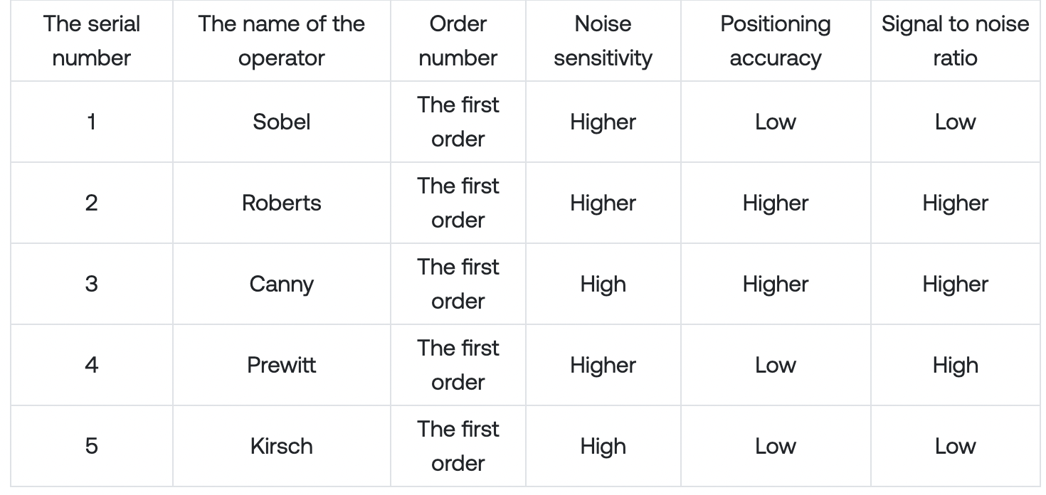

**CHAPTER 4**

**PROPOSED SOLUTIONS**

**4.1 PROPOSED APPROACH**

In order to solve these problem and improve the detection accuracy of traffic signal lights, in this paper improvements of the YOLOv8 algorithm are investigated. The shallow features are fused with deep features after up-sampling to realize the enhancement of shallow features and improve the positioning and color resolution ability of the YOLOv8 algorithm for small targets. The Gaussian model is used to process the coordinates of the predicted bounding box and calculate the uncertainty of the bounding box in order to improve the reliability of the predicted bounding box and further improve the detection performance of the YOLOv8 algorithm for small targets.

**YOLOv8 Algorithm** *:*

***4.1.1 The Principle of YOLOv8 Algorithm***

The YOLOv8 algorithm divides the network input into *S* × *S* grid units; then, each grid unit predicts *B* bounding boxes, the bounding box confidence, and *C* category probabilities. The confidence of the predicted bounding box reflects whether the predicted bounding box contains objects and the accuracy of the position when the objects are included. The accuracy is expressed as the intersection over union (IOU) of the predicted bounding box and the real bounding box according to Equation (1).

*confidence* = Pr(object) × IOU*truth* *pred*

where *confidence* is the confidence of the bounding box and Pr(object) is the probability of the object being detected in the grid.

By setting the category confidence threshold, the bounding boxes with a category confidence higher than the threshold are screened out and the non-maximum suppression algorithm is used to obtain the final bounding box. The predicted bounding box includes the four parameters *tx*, *ty*, *tw*, and *th*. In order to reduce the influence of singular samples on the network, the YOLOv8 algorithm normalizes the above parameters. As shown in Figure 1, the network input is an image with a size of 608 × 608. The input image is divided into 19 × 19 grid units. The width and height of the entire image are *widthimg* and *heightimg*, respectively, which are divided into s × s grid units. The dotted line is the predicted bounding box. The center point coordinates are (*x*0,*y*0) and the grid position of the center point is (*row*,*col*). The width and height of the bounding box are *widthbox* and *heightbox*, respectively. The normalization method is described as follows.

Boundary box width and height normalization according to Equations (2) and (3), respectively.

*tw* = *widthbox/widthimg*

*th* = *heightbox/heightimg*

Center point coordinate normalization according to Equations (4) and (5).

*tx* = *x*0 · *s widthimg* − *col*

*ty* = *y*0 · *s heightimg* − *row*

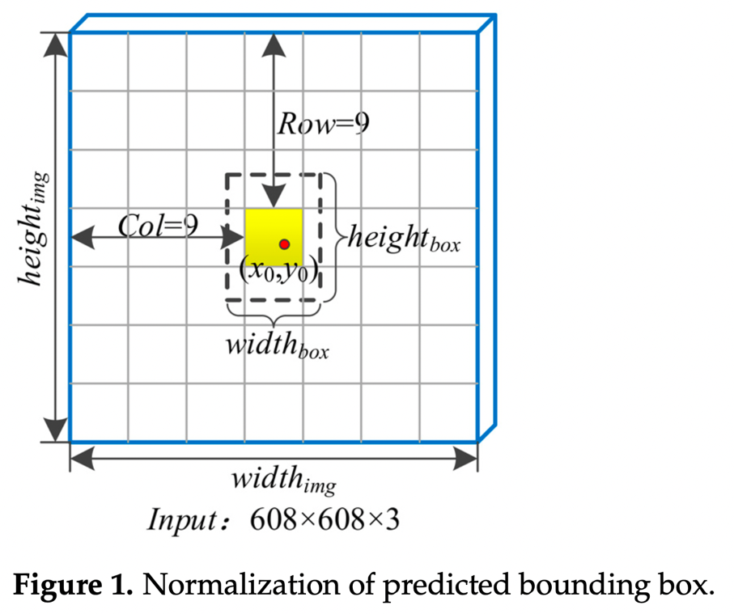

***4.1.2. CSPDarknet-53 Feature Extraction Network***

The CSPDarknet-53 feature extraction network is based on Darknet-53 and optimized by adding a cross-stage feature fusion strategy. To prevent repeated gradient information from being obtained in different layers, the idea of splitting and fusion is introduced across stages to maximize the differences in gradient combinations. In the process of split- ting and fusion, the gradient flow is truncated, meaning that the gradient information will not be reused and the generation of redundant information will be minimized. Applying the cross-stage feature fusion strategy to the local network of Darknet-53 can reduce the computational complexity of the feature extraction network and improve the speed and accuracy of the network’s reasoning. The cross-stage feature fusion strategy is shown in Figure 2.

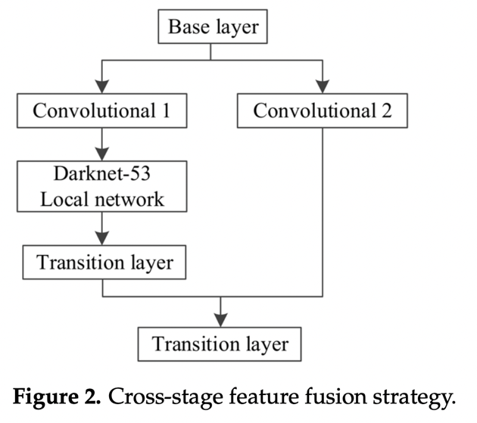

CSPDarknet-53 retains the original 52 convolutional layers in Darknet-53 and adds a cross-stage feature fusion strategy to the Darknet-53 local network to effectively reduce the possibility of duplication in the information integration process. The network structure diagram is shown in Figure 3.

Compared with Darknet-53, CSPDarknet-53 can greatly reduce the amount of cal- culation necessary, increase the network inference speed, reduce the network memory consumption, and improve the network accuracy.

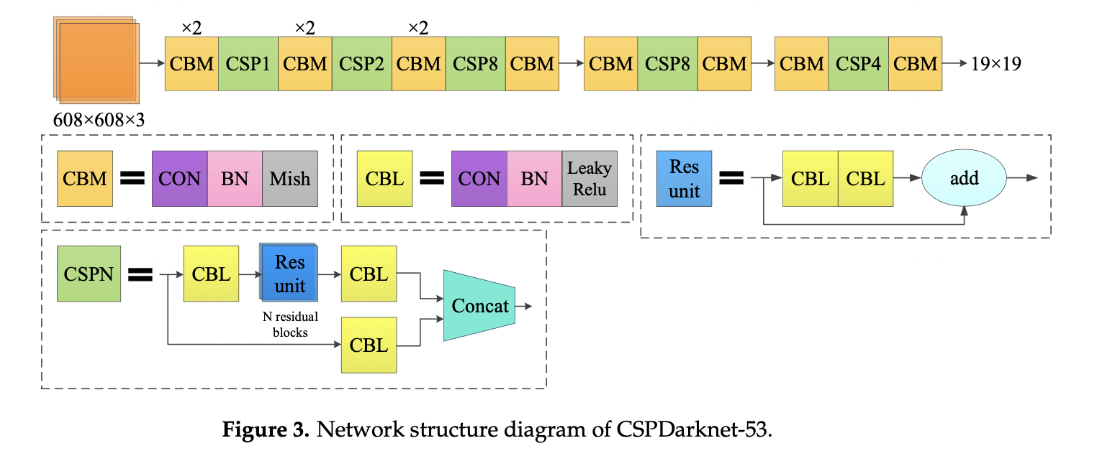***4.1.3 YOLOv8 Algorithm Loss Function***

The loss function of the YOLOv8 algorithm is composed of three parts: the prediction error of the bounding box coordinates, the confidence error of the bounding box, and the category prediction error. The calculation formula of the loss function of the YOLOv8 algorithm is shown as Equation (6), and the meaning of each parameter of the loss function are shown in Table 1.

**4.2 YOLOv8 Algorithm Network Improvement**

In order to improve its ability to detect small targets, the YOLOv8 algorithm network needs to be improved. A method for shallow feature enhancement is proposed to improve the network’s ability to locate small targets, improve its color resolution, and enhance its sensitivity for small target detection. The bounding box uncertainty prediction mechanism is introduced to improve the reliability of predicting the bounding box.

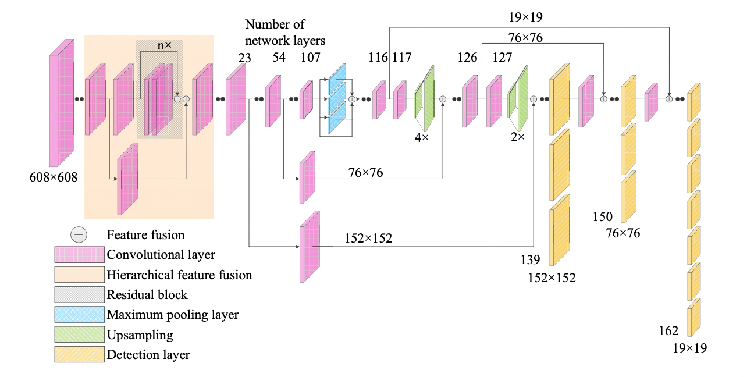

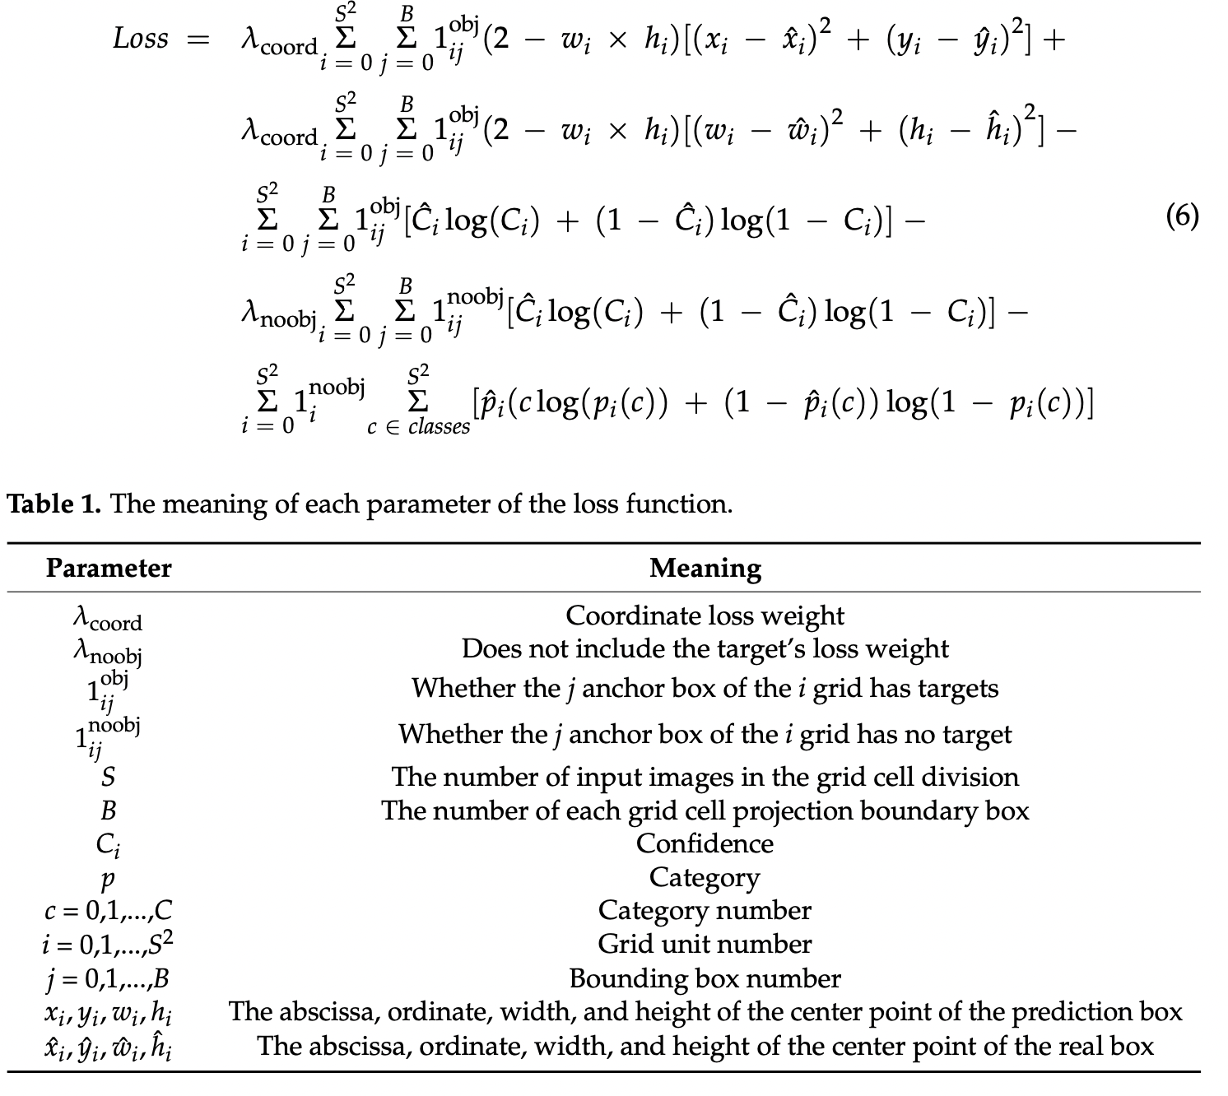

***4.2.1 Uncertainty Prediction of Bounding Box***

The bounding box prediction of the original YOLOv8 algorithm only predicts the coordinate information, while the accuracy of the bounding box is not processed. Consequently, the accuracy of the predicted bounding box coordinates cannot be judged from the results. In order to further strengthen the YOLOv8 algorithm’s ability to detect traffic lights, a bounding box uncertainty prediction mechanism is added to the YOLOv8 algorithm to predict the uncertainty of each coordinate information and improve the accuracy of the predicted bounding box.

In the original YOLOv8 algorithm, the coordinate information (*tx* and *ty*) of the center point of the bounding box and the size information (*tw* and *th*) of the bounding box are extracted through bounding box regression. However, these parameters can only provide the position and size of the bounding box and cannot represent the reliability of the bounding box. In this paper, the uncertainty calculation is added to the calculation of the confidence level and a single Gaussian model of *tx*, *ty*, *tw*, and *th* is used to model the uncertainty of the prediction frame.

*p*(*y*|*x*) = *N*(*y*;*μ*(*x*),Σ(*x*))

where *μ*(*x*) represents the mean function and ∑(*x*) represents the variance function.  
To predict the uncertainty of the bounding box, the coordinate information of the predicted bounding box is modeled as the mean and variance. The outputs of the bounding box are *μ*ˆ*tx* , Σˆ *tx* , *μ*ˆ*ty* , Σˆ *ty* , *μ*ˆ*tw* , Σˆ *tw* , *μ*ˆ*th* , and Σˆ *th* . Due to the detection layer structure in the network, the Gaussian parameters of *tx*, *ty*, *tw*, and *th* are preprocessed using the Sigmoid function.

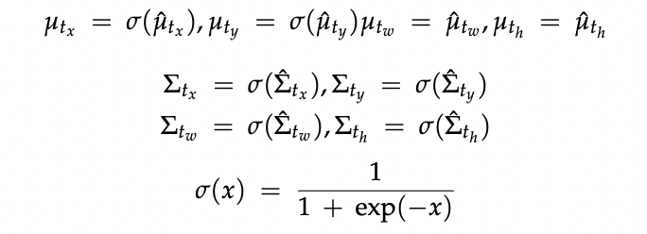

The average value of each coordinate in the detection layer is the predicted coordinate of the bounding box, and each variance represents the uncertainty of its corresponding coordinate. *μ*ˆ*tx* and *μ*ˆ*ty* represent the center coordinates of the bounding box in the grid, so the Sigmoid function is used to process it as a value between 0 and 1. *μtw* and *μth* represent *tw* and *th* in YOLOv8. Since their scale changes may exceed the grid size of the center point of the bounding box, the Sigmoid function is not used for processing. The variance of each coordinate information is processed by the Sigmoid function to be between 0 and 1. In the Gaussian distribution, the greater the variance is, the greater the change in the distribution will be. Since each variance represents the uncertainty of its corresponding coordinate, the closer the processed variance is to 0, the smaller the uncertainty will be and the more reliable the predicted bounding box will be; the closer it is to 1, the greater the uncertainty will be and the less reliable the predicted bounding box will be.

The change in the calculation method of the bounding box confidence during prediction is calculated.

*confidence* = Pr(object) × IOU*truth* × (1 − *Uncertaintyaver*)*pred*

where *Uncertaintyaver* is the mean value of the uncertainty for each coordinate’s information. Compared with the large target, if a bounding box of the same size is used in the detection of the small target, the variance will be large due to the small target occupying fewer pixels, resulting in a low confidence of the bounding box, and the bounding box can easily be abandoned. In small target detection, the variance of the bounding box with a smaller size is smaller and the mean value obtained for the uncertainty will be smaller, leading to the higher confidence of the predicted bounding box. By setting the category confidence threshold, the bounding boxes with a category confidence higher than the threshold are screened out, and the redundant prediction boundary boxes are removed by a non-maximum suppression algorithm to obtain the final boundary boxes. In other words, by adding the bounding box uncertainty prediction mechanism to the YOLOv8 algorithm, the predicted bounding box with smaller parameters becomes more suitable for small target detection tasks.

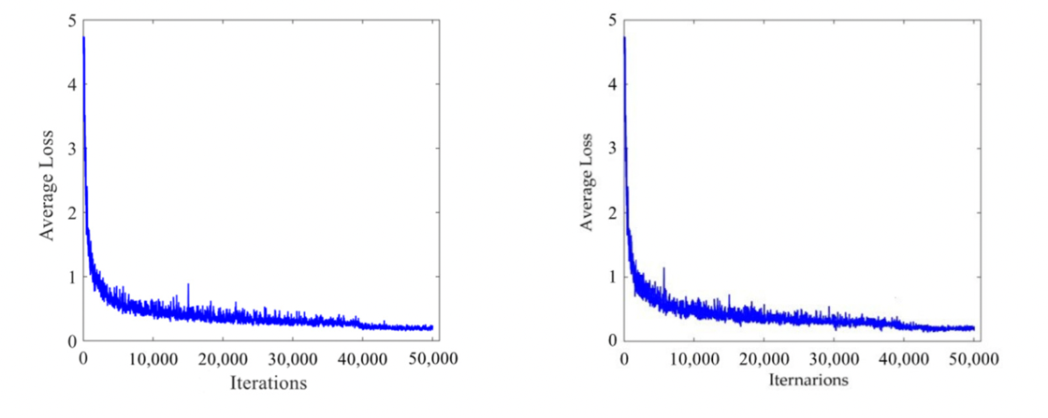

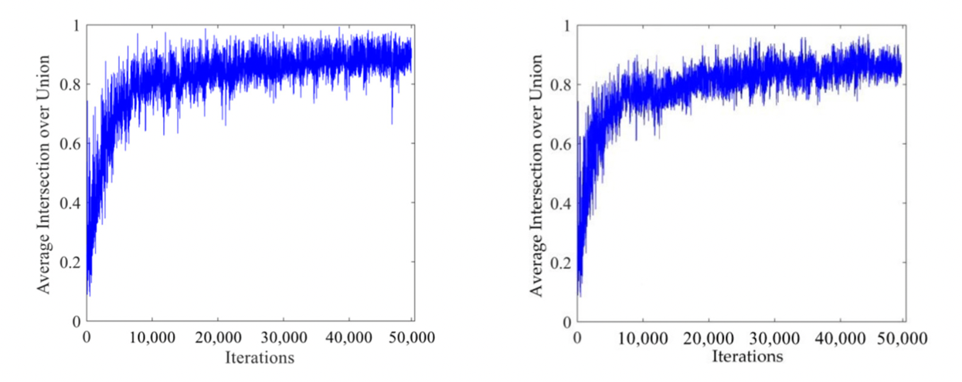

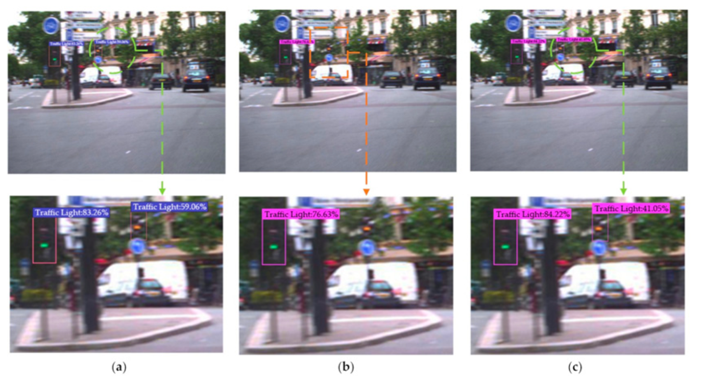

**CHAPTER 5**

**IMPLEMENTATION**

**5.1 ENVIRONMENT SETUP**

**Installing Python:**

1. To download and install Python visit the official website https://www.python.org/downloads/ and choose your version of Python

2. Once the download is complete, run the exe to install Python. Now click on Install Now.

3. You can see Python installed at this point.

4. When it finishes, you can see a screen that says the Setup was successful. Now click on “Close”.

**Installing and Configuration of PIP**

To install and configure pip on your computer, follow these instructions:

Note: The steps may vary slightly depending on your operating system. The following instructions assume you are using a Windows operating system.

1. Check if pip is already installed: Open a command prompt by pressing the Windows key + R,

type "cmd", and press Enter. In the command prompt, enter the following command and press Enter: pip --version

If you see output similar to `pip x.x.x from ...`, it means pip is already installed, and you can proceed to the configuration step. If you see an error or no output, move on to the installation step.

2. Install pip:

a) Download the get-pip.py script by visiting the official pip website: https://pip.pypa.io/en/stable/installing/

b) Right-click on the "get-pip.py" link and select "Save Link As" to save the file.

c)Open a command prompt and navigate to the directory where you saved the get-pip.py file using the `cd` command. For example, if you saved it in the Downloads folder, you would run: cd C:\Users\YourUsername\Downloads

d)Once you are in the correct directory, run the following command to install pip: python get-pip.py

Note: If you have multiple versions of Python installed, specify the Python version you want to use by replacing `python` with `python3` or `python2` accordingly.

3. Verify the installation:  
In the command prompt, enter the following command and press, Enter: pip --version. If you see output similar to `pip x.x.x from ...`, it means pip is installed successfully.

4. Configure pip:

a) Add the pip installation directory to the system's PATH environment variable to make it accessible from any location in the command prompt:

b) Right-click on the "This PC" or "My Computer" icon on your desktop and select "Properties".

c)Click on "Advanced system settings" on the left side of the window.

d)In the System Properties window, click on the "Environment Variables" button.

e) In the Environment Variables window, locate the "Path" variable under "System variables" and click on "Edit".

f) Add a new entry for the pip installation directory. By default, it is something like `C:\PythonXX\Scripts\` (replace `XX` with your Python version number).

g) Click "OK" to save the changes.

Note: If you had any command prompt windows open before modifying the PATH variable, you need to restart them for the changes to take effect.

After following these steps, you should have pip installed and configured on your computer. You can now use pip to install Python packages and libraries by running commands like `pip install package-name` in the command prompt.

**Installing NumPy**

To install a specific version of NumPy (version 1.19.2) using pip, follow these instructions:

1. Open a command prompt or terminal on your computer.

2. Type the following command and press Enter to execute it:

pip install numpy==1.19.2

This command tells pip to install NumPy version 1.19.2.

Note: Make sure you have pip installed and configured properly on your system. If you encounter any issues, you may need to upgrade pip or check your Python installation.

3. Wait for the installation process to complete. Pip will download and install the specified version of NumPy.

Once the installation is finished, you can use NumPy version 1.19.2 in your Python programs. Remember to import the module in your code using `import numpy`.

**Installing Moviepy:**

There are two main ways to install MoviePy:

1. Using pip

pip is a package manager for Python packages. To install MoviePy using pip, open a terminal and run the following command:

pip install moviepy

This will install MoviePy and all of its dependencies.

2. Using conda

conda is another package manager for Python packages. To install MoviePy using conda, open a terminal and run the following command:

conda install -c conda-forge moviepy

This will install MoviePy and all of its dependencies.

Once MoviePy is installed, you can import it into your Python code using the following import statement:

Python

import moviepy.editor as mpe

You can then use the MoviePy API to perform various video processing tasks, such as cutting, merging, and adding effects to videos.

* + MediaInfo

You can install FFmpeg and MediaInfo using your package manager or by downloading and installing the pre-built binaries from their websites.

**Installing Ultralytics**

Ultralytics provides various installation methods including pip, conda, and Docker. Install YOLOv8 via the ultralytics pip package for the latest stable release or by cloning the [Ultralytics GitHub repository](https://github.com/ultralytics/ultralytics) for the most up-to-date version. Docker can be used to execute the package in an isolated container, avoiding local installation.

Install the ultralytics package using pip, or update an existing installation by running pip install -U ultralytics. Visit the Python Package Index (PyPI) for more details on the ultralytics package: <https://pypi.org/project/ultralytics/>.

!pip install ultralytics==8.0.0

!pip install roboflow

import cv2

import pandas as pd

import numpy as np

from IPython.display import Image

from moviepy.editor import *

from ultralytics import YOLO

**5.2 IMPLEMENTATION**

**Step 1: Download Dataset from Roboflow**

from roboflow import Roboflow

rf= Roboflow(api_key="8joVH7TL2k5V6uScFBEy")

project=rf.workspace("roboflow-100").project("road-signs-6ih4y")

dataset = project.version(2).download("yolov8")

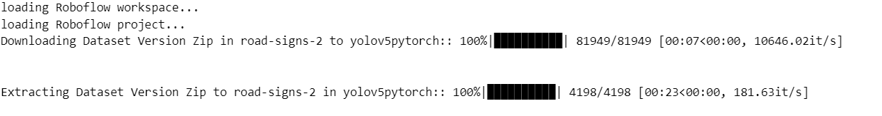

## ****Step 2: Implement the YOLOv8 model on Training Data****

Train the Pretrained YoloV8 model on Custom Dataset by using **model.train()**.

# Use the model

model.train(data="/content/drive/MyDrive/summer/datasets1/road_signs/data.yaml", epochs=25) # train the model

## ****Step 3: Evaluate model performance on Validation Dataset****

Test the Pretrained YoloV8 model on valid Data by using **model.val()**.

# evaluate model performance on the validation set

metrics = model.val()

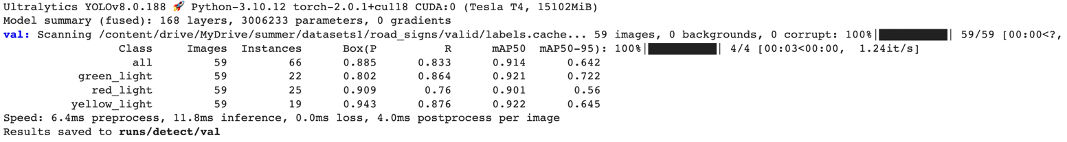

path = model.export(format="onnx")  # export the model to ONNX format

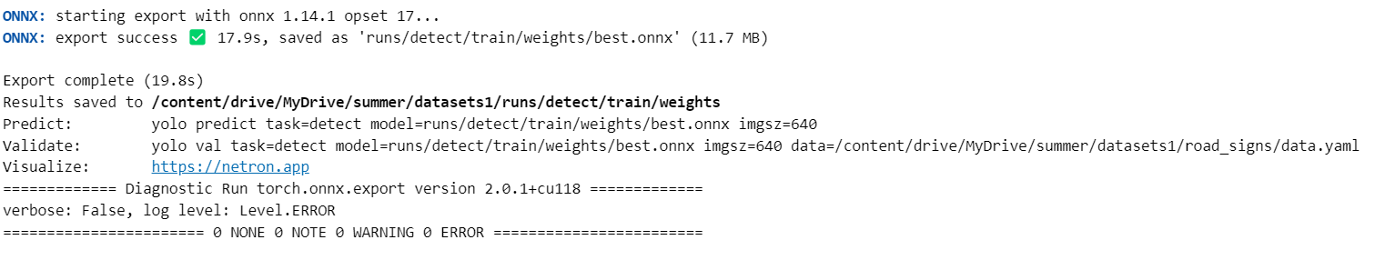

**ONNX FORMAT:**

OPEN NEURAL NETWORK EXCHANGE FORMAT it is an open source standard that makes it easy to move Deep Learning models between different frameworks and hardware platforms.

It provides a set of tools for optimizing and quantizing models, and it is supported by a wide range of companies and organisations.

**Step 4: Implementing the Prediction Function**

**The prediction function is used to check for irregularities in the traffic light system**

**We check whether the light is jumping from Red to Green skipping Yellow light in the below code.**

def predict_on_video(video_file_path):

rg=set(['green_light','red_light'])

ryg=set(['green_light','red_light','yellow_light'])

results = model.predict(video_file_path,stream=True,save=True,conf=0.25)

list1 = []

for r in results:

for idx, prediction in enumerate(r.boxes.xywhn): # change final attribute to desired box format

cls = int(r.boxes.cls[idx].item())

name = r.names[cls]

list1.append(name)

a=set(np.unique(list1))

if a == rg:

return False

elif a ==ryg:

return True

**Step 5: Testing the function**

Testing the custom YoloV8 model stored as best.pt

model = YOLO('/content/drive/MyDrive/summer/datasets1/runs/detect/train/weights/best.pt')

predict_on_video("")

**CHAPTER 6**

**RESULTS**

**LOSS AND ACCURACY CURVES**

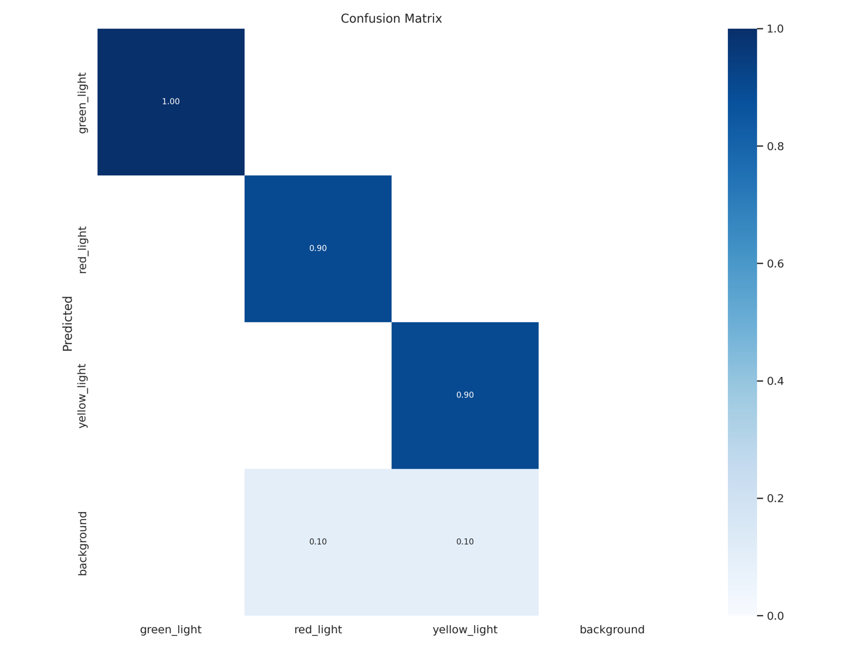

**RESULTS:**

The above table signifies the

* True positive
* True negative
* False positive
* False negative

Green light has 100 percentage of accuracy on the validation data.

Red light has 90 percentage of accuracy / true positive rate on validation data.

Yellow light has 90 percentage of accuracy rate on validation data**.**

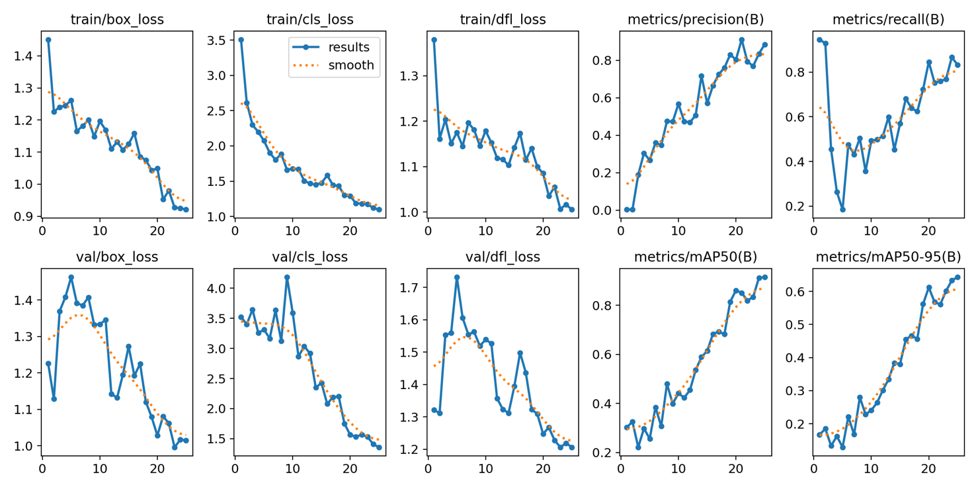

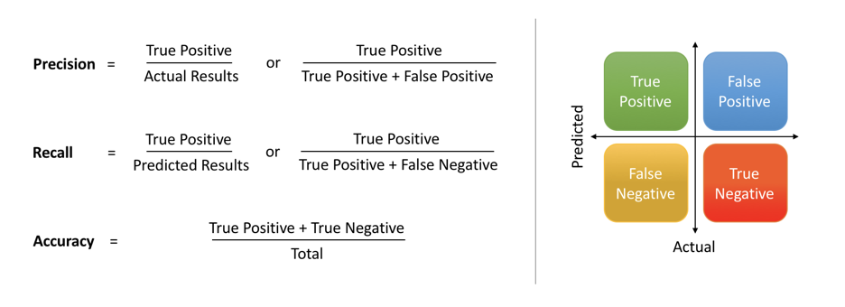

The models have 25 epochs.

As epochs grow the validation and training looses have reduced.

The Recall has fallen sharply due to over fitting in lower epochs as the models trains, the recall increases. Indicating the True positives have increased.

Precision results have continuous increased.

Image(filename=f"/content/drive/MyDrive/summer/datasets1/runs/detect/train/train_batch0.jpg",height=500)

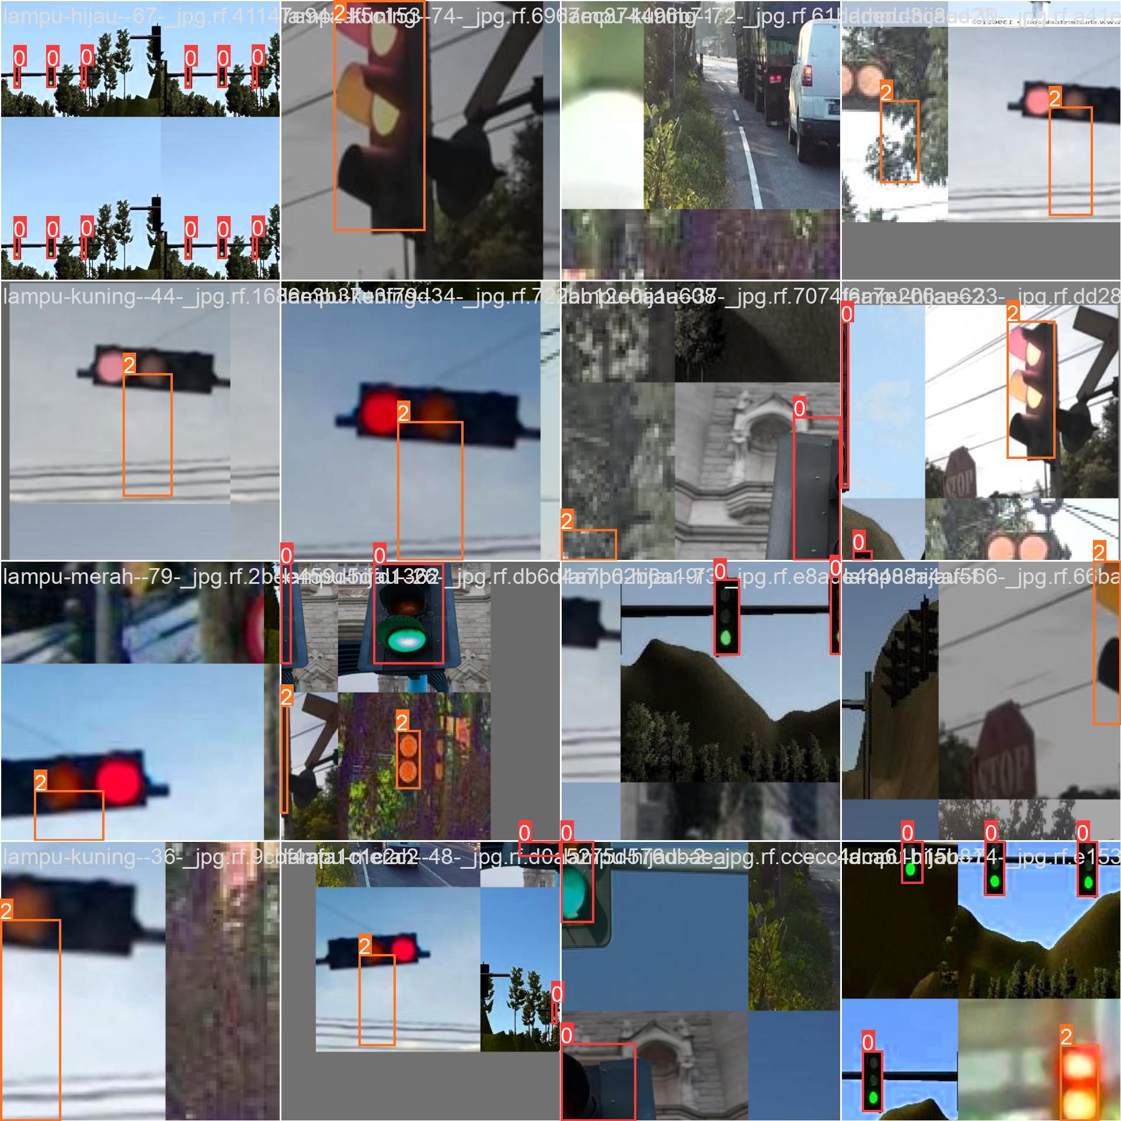

**0 – means green**

**1 – means yellow**

**2 – means red.**

Image(filename=f"{HOME}/runs/detect/train2/val_batch0_labels.jpg",height=500)

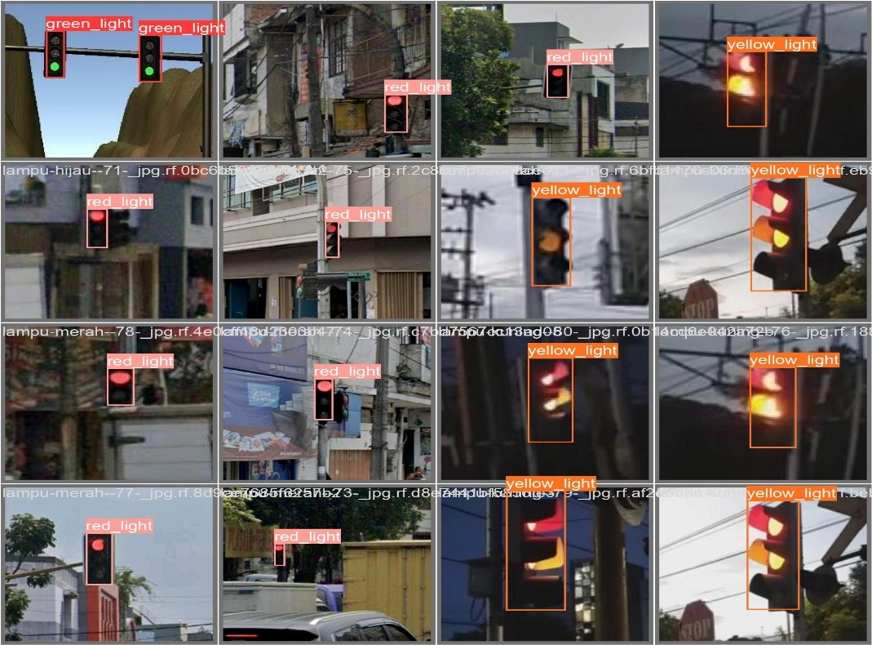

Image(filename=f"{HOME}/runs/detect/train2/val_batch0_labels.jpg",height=500)

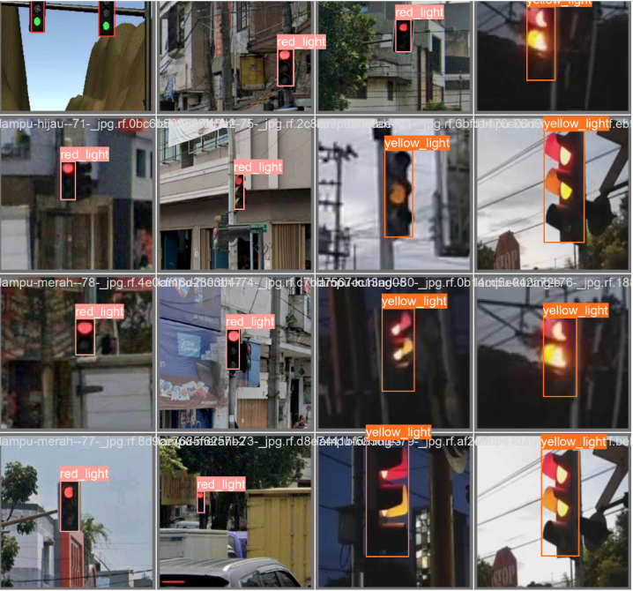

Here labels are used instead of labels as 0,1,2.

***Testing of predict_on_video() function on video:***

predict_on_video("D:\\test folder\\test videos\\ryg\\istockphoto-499716090-640_adpp_is.mp4")

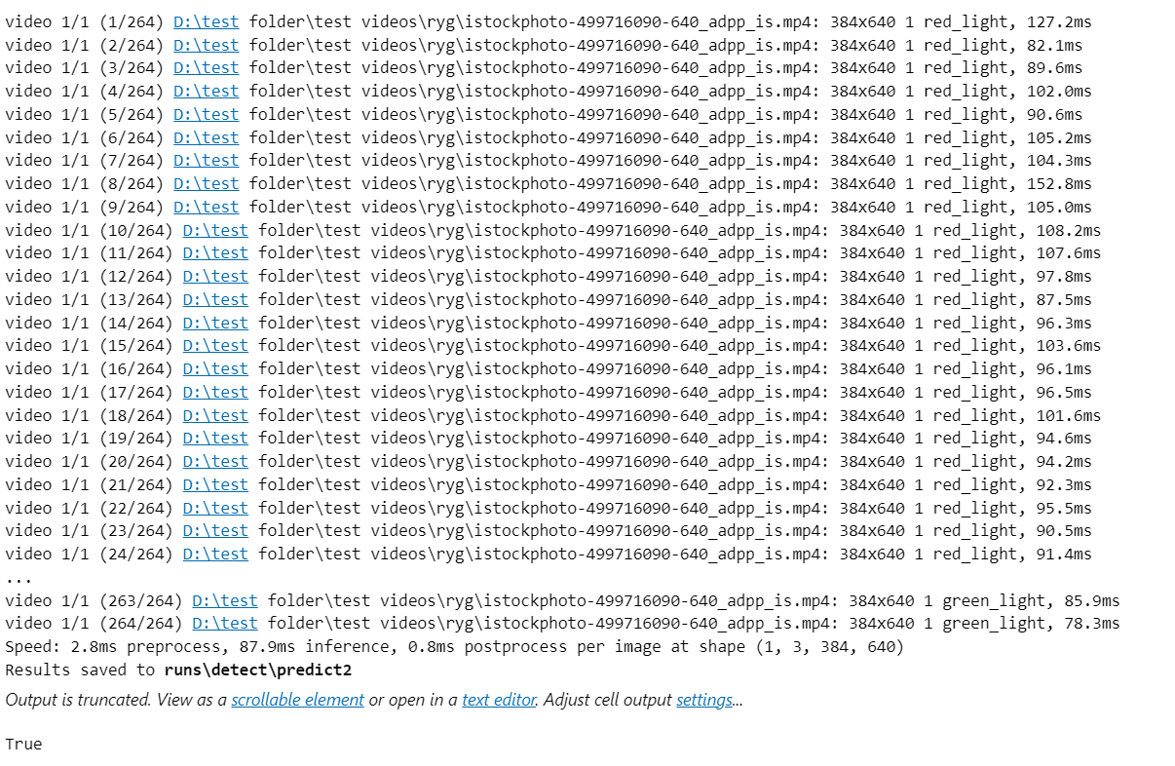

path="D:\\test folder\\traffic_lights\\runs\\detect\\predict\\istockphoto-499716090-640_adpp_is.avi"

clip=VideoFileClip(path)

clip.ipython_display(width=600)

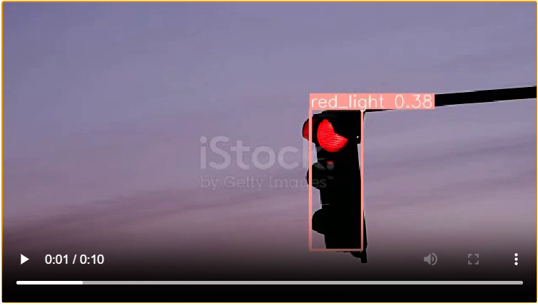

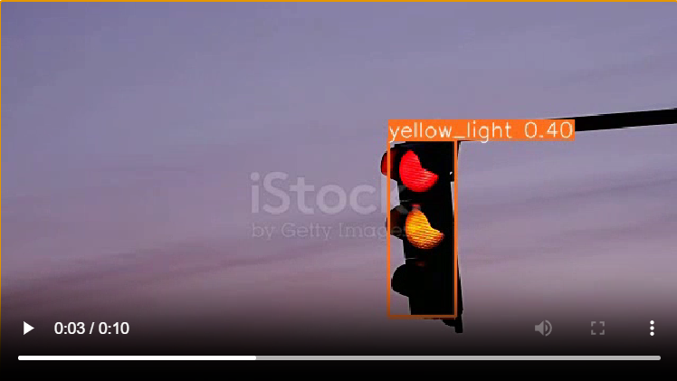

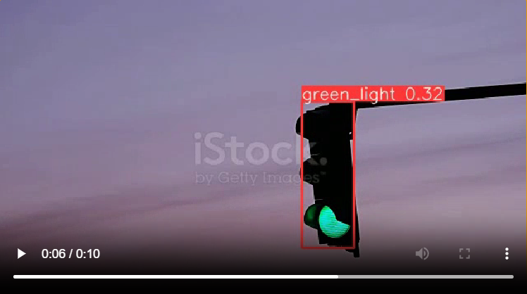

Screenshots of the video : as it transitions from red to yellow to green

The video predicts ***True.***

predict_on_video("D:\\test folder\\test videos\\rg\\istockphoto-848185796-640_adpp_is.mp4")

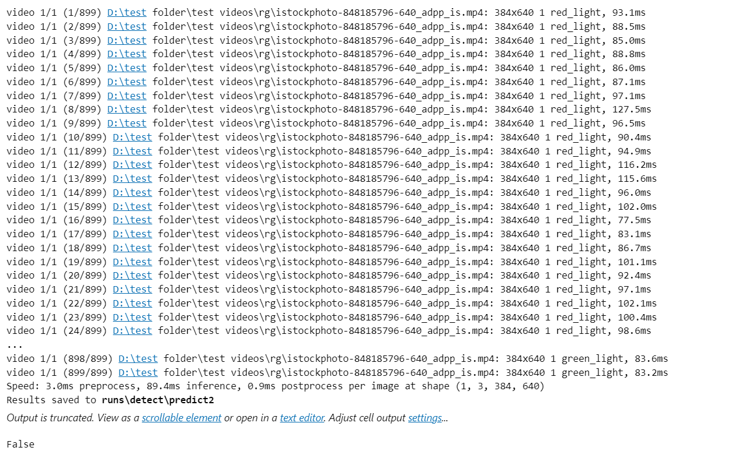

path="D:\\test folder\\traffic_lights\\runs\\detect\\predict\\istockphoto-848185796-640_adpp_is.avi"

clip=VideoFileClip(path)

clip.ipython_display(width=600)

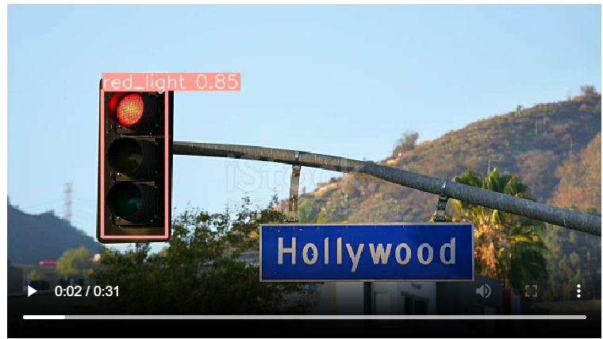

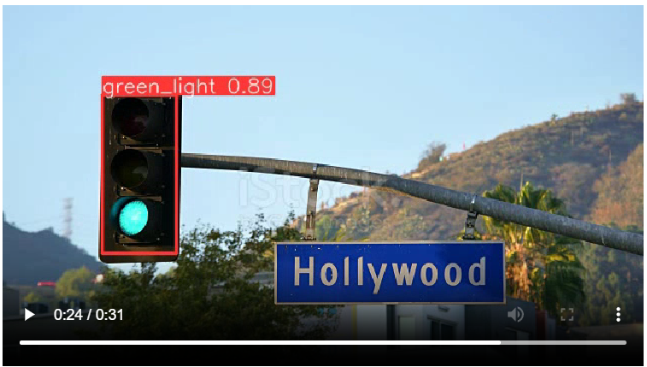

**Chapter 7**

**CONCLUSION AND FUTURE SCOPE**

We proposed the use of the Improved YOLOv8 algorithm for traffic light detection and recognition. This method involved adding a shallow feature enhancement mechanism and a bounding box uncertainty prediction mechanism. By using the Improved YOLOv8 algorithm, the problem that the YOLOv8 algorithm was not sensitive to small targets was effectively solved and the accuracy of the traffic light detection and recognition was greatly improved. The experimental analysis was performed with the LISA traffic light data set and the LaRa traffic light data set, and the following conclusions were obtained.

(1) A shallow feature enhancement mechanism was applied to optimize the YOLOv8 algorithm. The accuracy of traffic light detection and recognition was effectively improved. For the two data sets of LISA and LaRa, the AUC is increased to 97.03% and 95.31% in the traffic signal detection experiments, respectively, while mAP is increased to 81.34% and 78.88% in the recognition experiments, respectively. Due to the increase in the number of network calculations, the detection time was increased to 33.99 ms and 39.63 ms, respectively. The results show that the method can effectively improve the detection and recognition accuracy of traffic lights. Although the amount of network calculation necessary was increased slightly, the method could still realize the real-time detection and recognition of traffic lights.

(2)A bounding box uncertainty prediction mechanism was applied to optimize the YOLOv8 algorithm, which effectively improved the accuracy of the YOLOv8 algo- rithm in the detection and recognition of traffic lights. The accuracy of traffic light detection and recognition was effectively improved. For the two data sets of LISA and LaRa, the AUC was increased to 96.84% and 94.73% in the traffic signal detection experiments and the mAP was increased to 79.93% and 78.23% in the recognition experiments. The detection time was reduced to 27.59 ms and 33.45 ms, respectively. The results show that, compared with the improved YOLOv8 algorithm, this method had little difference in detection and recognition speed but effectively improved the accuracy of the YOLOv8 algorithm in the detection and recognition of traffic lights.

(3)The Improved YOLOv8 algorithm involved using the two optimization methods, the shallow feature enhancement mechanism, and the bounding box uncertainty prediction mechanism. For the two data sets of LISA and LaRa, the AUC was in- creased by 1% and 1.19% in the traffic light detection experiments compared with the original YOLOv8 algorithm, respectively. In the recognition experiments, the mAP was improved by 2.86% and 2.56% compared with the original YOLOv8 algorithm, respectively. The robustness of the Improved YOLOv8 algorithm was evidenced by the significant reduction in the missed and false detection cases under complex traffic signal light backgrounds, such as strong illumination, target blocking, and evening. Additionally, when the improved YOLOv8 algorithm was tested on data sets collected by different cameras, the AUC and mAP are improved, which also proved the scalability of the algorithm. Although the calculation cost increased due to the increase in the number of network calculations, the increased detection time was only at the ms level, which could also ensure the real-time detection of traffic lights. This shows that the method described in this paper is a feasible method for use in real scenarios.

**Prospective investigations**: It is still a challenge to avoid missed and false detections of traffic lights due to the complexity and changeability of the background in traffic light detection scenarios. Considering the effectiveness of the Improved YOLOv8 algorithm in reducing the number missed and false detection cases, the target tracking should be focused on the identified traffic light to predict the movement trajectory and status of the traffic light relative to the vehicle in order to further improve the reliability of the Improved YOLOv8 algorithm for the detection and recognition of traffic lights.

**CHAPTER 8**

**REFERENCES**

**References**

1. Wang, Z.-Y.; Miao, D.-Q.; Zhao, C.-R.; Luo, S.; Wei, Z.-H. Pedestrian tracking and detection combined algorithm based on multi-granularity features. *Comput. Res. Dev.* **2020**, *57*, 996–1002.
2. Xiang, N.; Cao, Z.; Wang, Y.; Jia, Q. A Real-Time Vehicle Traffic Light Detection Algorithm Based on Modified YOLOv3. In Proceedings of the 2021 IEEE 4th International Conference on Electronics Technology, Chengdu, China, 7–10 May 2021; pp. 844–850.
3. Sun, Y.-C.; Pan, S.-G.; Zhao, T.; Gao, W.; Wei, J.-S. Traffic Light Detection Based on YOLOv3 Optimization Algorithm. *Acta Opt. Sin.* **2020**, *40*, 143–151.
4. Cai, Z.-X.; Gu, M.-Q. Accurate Recognition and State Estimation of Traffic Lights in Urban Environment. *Control. Decis.* **2014**, *29*, 163–167.
5. Philipsen, M.P.; Jensen, M.B.; Møgelmose, A.; Moeslund, T.B.; Trivedi, M.M. Traffic Light Detection: A Learning Algorithm and Evaluations on Challenging Dataset. In Proceedings of the 2015 IEEE 18th International Conference on Intelligent Transportation Systems, Gran Canaria, Spain, 15–18 September 2015; IEEE: Piscataway, NJ, USA, 2015; pp. 2341–2345.
6. Du, X.-P.; Li, Y.; Guo, Y.; Xiong, H. Vision-Based Traffic Light Detection for Intelligent Vehicles. In Proceedings of the 2017 4th International Conference on Information Science and Control Engineering, Changsha, China, 21–23 July 2017; IEEE: Piscataway, NJ, USA, 2017; pp. 1323–1326.
7. Li, Z.-X.; Qin, B.; Wang, M.-Q. Real-time Detection and Recognition of Traffic Signal Lights Based on Time-space Relationship Model. *Comput. Sci.* **2018**, *45*, 314–319.
8. Behrendt, K.; Novak, L.; Botros, R. A Deep Learning Approach to Traffic Lights: Detection, Tracking, and Classification. In Proceedings of the 2017 IEEE International Conference on Robotics and Automation, Singapore, 29 May–3 June 2017; IEEE: Piscataway, NJ, USA, 2017; pp. 1370–1377.
9. Pan, W.-G.; Chen, Y.-H.; Liu, B.; Shi, H.-L. Detection and Recognition of Traffic Lights Based on Faster R-CNN. *Transducer Microsyst. Technol.* **2019**, *38*, 147–149.
10. Morten, B.J.; Kamal, N.; Thomas, B. Evaluating State-of-the-art Object Detector on Challenging Traffic Light Data. In Proceedings of the 2017 IEEE Conference on Computer Vision and Pattern Recognition, Honolulu, HI, USA, 21–26 July 2017; IEEE: Piscataway, NJ, USA, 2017; pp. 882–888.
11. Muller, J.; Dietmayer, K. Detecting Traffic Lights by Single Shot Detection. In Proceedings of the 21st IEEE International Conference on Intelligent Transportation Systems, Maui, HI, USA, 4–7 November 2018; IEEE: Piscataway, NJ, USA, 2018; pp. 266–273.
12. Possatti, L.C.; Guidolini, R.; Cardoso, V.B.; Berriel, R.F.; Paixão, T.M.; Badue, C.; de Souza, A.F.; Oliveira-Santos, T. Traffic

Light Recognition Using Deep Learning and Prior Maps for Autonomous Cars. In Proceedings of the 2019 International Joint

Conference on Neural Networks, Budapest, Hungary, 14–19 July 2019; IEEE: Piscataway, NJ, USA, 2019; pp. 1–8.

1. Du, L.; Chen, W.; Fu, S.; Kong, H.; Li, C.; Pei, Z. Real-time Detection of Vehicle and Traffic Light for Intelligent and Connected Vehicles Based on YOLOv3 Network. In Proceedings of the 2019 5th International Conference on Transportation Information and

Safety, Liverpool, UK, 14–17 July 2019; IEEE: Piscataway, NJ, USA, 2019; pp. 388–392.

1. Wang, L.; Zhou, K.; Chu, A.; Wang, G.; Wang, L. An Improved Light-Weight Traffic Sign Recognition Algorithm Based on

YOLOv8-Tiny. *IEEE Access* **2021**, *9*, 124963–124971. [CrossRef]

1. Peng, J.; Xu, M.; Yan, Y. Automatic Recognition of Pointer Meter Reading Based on YOLOv8 and Improved U-net Algorithm. In

Proceedings of the 2021 IEEE International Conference on Electronic Technology, Communication and Information (ICETCI),

Changchun, China, 27–29 August 2021; IEEE: Piscataway, NJ, USA, 2021; pp. 52–57.

1. Li, Z.; Zeng, Q.; Liu, Y.; Liu, J.; Lin, L. An improved traffic lights recognition algorithm for autonomous driving in complex

scenarios. *Int. J. Distrib. Sens. Netw.* **2021**, *17*, 15501477211018374. [CrossRef]

1. Wang, J.-Q.; Li, J.-S.; Zhou, X.-W.; Zhang, X. Improved SSD Algorithm and Analysis of Small Target Detection Performance in

Remote Sensing Images. *Acta Opt. Sin.* **2019**, *39*, 373–382.

1. Wang, C.-Y.; Liao, M.H.-Y.; Yeh, I.H.; Wu, Y.-H.; Chen, P.-Y.; Hsieh, J.-W. CSPNet: A New Backbone that can Enhance Learning

Capability of CNN. In Proceedings of the IEEE/CVF conference on computer vision and pattern recognition workshops,

Washington State Convention Center, Seattle, WA, USA, 14–19 June 2020; pp. 390–391.

1. He, Y.; Zhu, C.; Wang, J.; Savvides, M.; Zhang, X. Bounding Box Regression with Uncertainty for Accurate Object Detection. In

Proceedings of the 2019 IEEE Conference on Computer Vision and Pattern Recognition, Long Beach, CA, USA, 15–20 June 2019;

IEEE: Piscataway, NJ, USA, 2019; pp. 2883–2892.

1. Akshayaa, S.; Nithin, S. Comparative study of pedestrian detection techniques for driver assistance system. In Proceedings of the

2021 Second International Conference on Electronics and Sustainable Communication Systems (ICESC), Coimbatore, India, 4–6

August 2021; IEEE: Piscataway, NJ, USA, 2021; pp. 1450–1454.

1. Morten, B.J.; Philipsen, M.P.; Andreas, M. Vision for Looking at Traffic Lights: Issues, Survey, and Perspectives. *Trans. Intell.*

*Transp. Syst.* **2016**, *17*, 1800–1815.

1. Loshchilov, I.; Hutter, F. SGDR: Stochastic Gradient Descent with Warm Restarts. *arXiv* **2016**, arXiv:1608.03983.

**CHAPTER 9**

**APPENDIX**

**Python**

One of the most popular languages is Python. Guido van Rossum released this language in 1991. Python is available on the Mac, Windows, and Raspberry Pi operating systems. The syntax of Python is simple and identical to that of English. When compared to Python, it was seen that the other language requires a few extra lines.

It is an interpreter-based language because code may be run line by line after it has been written. This implies that rapid prototyping is possible across all platforms. Python is a big language with a free, binary-distributed interpreter standard library.

It is inferior to maintenance that is conducted and is straightforward to learn. It is an

object-oriented, interpreted programming language. It supports several different programming paradigms in addition to object-oriented programming, including functional and procedural programming.

It supports several different programming paradigms in addition to object-oriented programming, including practical and procedural programming. Python is mighty while maintaining a relatively straightforward syntax. Classes, highly dynamic data types, modules, and exceptions are covered. Python can also be utilised by programmes that require programmable interfaces as an external language.

**Python Features:**

1) **Eas**y: Because Python is a more accessible and straightforward language, Python

programming is easier to learn.

2) **Interpreted language:** Python is an interpreted language, therefore it can be used to examine the code line by line and provide results.

3) **Open Source:** Python is a free online programming language since it is open-source.

4) **Portable:** Python is portable because the same code may be used on several computer

standard libraries: Python offers a sizable library that we may utilize to create applications

quickly.

6) **GUI:** It stands for GUI (Graphical User Interface)

7) **Dynamically typed:** Python is a dynamically typed language, therefore the type of the value will be determined at runtime.

**Machine Learning**

Artificial intelligence (AI), which includes machine learning, enables computer systems to learn without being explicitly programmed. It has to do with statistics and applied mathematics. Mike Robert's definition of machine learning. As a computer gathers and learns from the data it provides, it may operate more correctly via machine learning.

For large classes of machine learning, many algorithms are used. We must provide algorithms with more precise data for them to complete certain jobs. In some circumstances, a computer will utilise data to gather information, check its output against the desired outcome, and make necessary corrections.

For instance, when someone texts on a phone, the phone learns about spelling errors and either autocorrects the offending word or suggests a replacement. For many top organisations, machine learning is a critical component of the creation of new products.

ML is an important factor in the operations of many companies, like Facebook and Google. Data science uses machine learning in many different ways. Data scientists rely on ML approaches to carry out their modelling. Regression and classification are of utmost relevance in data science; hence, the main tool utilised in ML is to accomplish such objectives.

ML applies applicable to practically all phases of data science and is most often associated with the data modelling phase. Python has been the primary computer language used for data

processing. Several Python packages are used in ML settings. The three sections of Python are huge data, optimising your code, and data files in memory.

**Types of Machine Learning**

There are three fundamental forms of machine learning: -supervising, semi-supervised, and

machine learning

**a)Supervised Machine Learning**

That method looks for patterns in the labelled data set to obtain results. Data labelling in

supervised learning requires human intervention. To train the algorithm with labelled inputs and the intended output, supervised ML requires human participation. ML under supervision is good for a task like;

I. Classify the data using a binary system into two groups.

II. **Multi-classification:** The division of data into more than two categories,

III. Modelling imaging continuous value using regression.

IV. **Assembling:** Compiling the estimates from many ML models to provide a precise estimate.

**b) Unsupervised Machine Learning**

This method searches for patterns in the data collection without relying on labelled data or

human interaction. Data labelling is not necessary for this strategy. ML Unsupervised is effective for tasks like;

I. **Dimensionality reduction:** Reduce the number of variables in the data collection.

II. **Clustering:** Grouping the dataset based on similarities.

III. Association mining identifies the item or group of items that commonly appear together in

data.

IV. Data point identification for anomaly detection in the data set.

**c)Semi-supervised Learning:**

For this method, you require labelled data. As a consequence, human interaction is also

necessary, but the process still moves forward. In this kind of learning, the algorithm is given a tiny quantity of labelled data by data scientists, and as a result, the algorithm gains knowledge about the data set's dimension, which it may then apply to mother del, unlabeled data.

There are several contexts in which semi-supervised machine learning (ML) may be used.

**Machine translation:** Language conversion using a learning system.

**Data labelling**: An algorithm trained on modest amounts of data will automatically apply data labels to enormous collections.

**Uses of Machine Learning**

Machine learning is used in many areas nowadays. The most well-known example is the

machine learning recommendation engine that drives a book's news feed. This engine makes an effort to reinforce established patterns in a user's online activity inside a certain Facebook group.

The news is appropriately adjusted if a user alters the design and doesn't read anything from that particular group the following week. Applications of machine learning (ML) include business intelligence, human resource information systems, autonomous vehicles, and virtual assistants.

**Advantages:**

• ML helps enterprises in comprehending their clients. ML assists in improving goods in

response to client demand by gathering the necessary user data and associating it with shifting

behaviour. Some companies' business models are heavily reliant on machine learning, such as

Uber, which uses an algorithm to connect drivers and customers. To surface the advertising in

searches, Google employs ML.

**Disadvantages:**

• ML might be expensive. High wages for machine learning are a result of data emotions

commanded on the project. These initiatives also often demand expensive software

infrastructure.

• In addition to that, when an algorithm is trained on a data set, ML bias might develop. That has flaws in it that might provide erroneous results.

**Steps to choosing the suitable ML model**

The issue is solved by selecting the best ML model, which might take some time. The steps are as follows:

1) For the difficulty with the pure date alignment, the input should be thought about.

2) Gather, label, and prepare the data as appropriate.

3) To put the right algorithms to use and test them to determine how well they perform.

LIBRARIES USED

Pandas:

Pandas is a versatile and widely used open-source library for data manipulation and analysis in Python. It provides high-performance, easy-to-use data structures and data analysis tools that make working with structured data efficient and intuitive.

One of the key features of Pandas is its powerful data structures: Series and DataFrame. The

Series is a one-dimensional labelled array capable of holding any data type, while the DataFrame is a two-dimensional table-like structure that organises data into rows and columns. These data structures allow for seamless handling and manipulation of data, including filtering, sorting, reshaping, and merging.

Pandas excels in data cleaning and preparation. It provides a rich set of functions to handle

missing data, duplicate values, and inconsistent data formats. It also offers flexible data

transformation capabilities, allowing users to apply custom functions to data or perform common operations like grouping, aggregation, and pivot tables.

Data analysis and exploration are made easy with Pandas. It supports efficient data indexing,

slicing, and filtering, enabling users to extract specific subsets of data quickly. It also integrates

well with other data analysis libraries in the Python ecosystem, such as NumPy, Matplotlib, and scikit-learn, providing seamless interoperability for advanced analysis and visualisation tasks.

Pandas is widely used in various domains, including finance, economics, social sciences, and

data-driven industries. It enables analysts and data scientists to perform data wrangling,

exploratory data analysis, and statistical modelling efficiently. Its flexibility, speed, and extensive functionality make it a go-to tool for data professionals working with structured data.

**NumPy:**

NumPy is a fundamental library in Python for scientific computing and numerical operations. It provides a powerful array object and a collection of functions for working with large,

multi-dimensional arrays and matrices efficiently.

One of the key features of NumPy is its ndarray (N-dimensional array) object, which enables

efficient storage and manipulation of homogeneous data. The ndarray allows for fast

mathematical operations on entire arrays, eliminating the need for explicit loops and greatly

improving performance.

NumPy offers a wide range of mathematical functions, including linear algebra operations,

Fourier transforms, random number generation, and more. It also provides tools for array

reshaping, slicing, and indexing, allowing users to extract and manipulate specific subsets of data easily.

The versatility of NumPy makes it a vital component in various domains, such as scientific

research, data analysis, machine learning, and image processing. It is heavily used in numerical computations, simulations, and data processing pipelines. Additionally, NumPy's compatibility with other libraries, such as Pandas and Matplotlib, enables seamless integration and enhances the overall data analysis and visualisation capabilities.

**YOLOv8:**

YOLOv8 is a real-time object detection algorithm that uses a single neural network to predict bounding boxes and class probabilities for multiple objects in an image. It is the latest version of the popular YOLO family of algorithms, and it offers a number of improvements over previous versions, including:

* Increased accuracy: YOLOv8 achieves state-of-the-art accuracy on a number of object detection benchmarks.
* Faster speed: YOLOv8 is faster than previous versions of YOLO, making it suitable for real-time applications.
* More robust: YOLOv8 is more robust to occlusions and other challenges than previous versions of YOLO.

YOLOv8 is based on the EfficientDet architecture, which is a single-stage object detection algorithm that uses a convolutional neural network (CNN) to extract features from an image and then uses a series of regression heads to predict bounding boxes and class probabilities for multiple objects.

YOLOv8 uses a number of techniques to improve the accuracy, speed, and robustness of the algorithm. These techniques include:

* Anchor-free prediction: YOLOv8 does not use anchors to predict bounding boxes. Instead, it predicts the center coordinates, width, and height of each bounding box directly. This makes YOLOv8 more robust to occlusions and other challenges.
* Spatial adaptive modulation: YOLOv8 uses a spatial adaptive modulation (SAM) module to improve the accuracy of the algorithm. SAM learns to modulate the features extracted by the CNN based on the spatial location of each object in the image. This helps YOLOv8 to better distinguish between different objects in the image.
* EfficientDet architecture: YOLOv8 is based on the EfficientDet architecture, which is a single-stage object detection algorithm that is designed to be both accurate and fast.

YOLOv8 can be used for a variety of real-time object detection applications, such as:

* Self-driving cars: YOLOv8 can be used to detect pedestrians, vehicles, and other objects on the road.
* Video surveillance: YOLOv8 can be used to detect people, vehicles, and other objects in video footage.
* Robotics: YOLOv8 can be used to help robots to navigate and interact with their environment.

**MoviePy:**

MoviePy is a Python library for video processing. It provides a wide range of features, including video cutting, video merging, video effects, and video transcoding. MoviePy is easy to use and can be used for a variety of video processing tasks, from simple video editing to complex video effects.

Here is a summary of the key features of MoviePy:

* Video cutting and merging: MoviePy can be used to cut and merge video clips. This can be useful for creating trailers, highlight reels, or simply trimming unwanted footage.
* Video effects: MoviePy can be used to add a variety of video effects to video clips, such as text overlays, transitions, and color correction.
* Video transcoding: MoviePy can be used to transcode video clips from one format to another. This can be useful for converting video clips to a format that is compatible with a particular device or platform.

MoviePy can be used for a variety of video processing tasks, including:

* Creating video trailers and highlight reels: MoviePy can be used to cut and merge video clips to create trailers and highlight reels.
* Editing home movies: MoviePy can be used to edit home movies by adding text overlays, transitions, and other effects.
* Creating educational videos: MoviePy can be used to create educational videos by adding text overlays, diagrams, and other visuals.
* Creating marketing videos: MoviePy can be used to create marketing videos by adding text overlays, animations, and other effects.

**IPython:**

IPython is a Python shell and interactive computing environment. It provides a number of features that make it more powerful and user-friendly than the standard Python shell, including:

* Interactive code execution: IPython allows you to execute Python code interactively, line by line. This makes it ideal for prototyping and debugging code.
* History and tab completion: IPython keeps a history of all of the commands that you have executed, and it provides tab completion for commands and variable names. This makes it easier to write and execute code quickly and accurately.
* Magic commands: IPython provides a number of magic commands that allow you to perform tasks such as loading data, changing the working directory, and running shell commands. This makes IPython a more versatile and powerful tool than the standard Python shell.

IPython is used by data scientists, researchers, and software developers for a variety of tasks, including:

* Data analysis: IPython can be used to load and analyze data from a variety of sources, such as CSV files, databases, and web APIs.
* Machine learning: IPython can be used to develop and train machine learning models.
* Scientific computing: IPython can be used to perform scientific calculations and simulations.
* Software development: IPython can be used to develop and test Python code.